

**Sponsor Handbook**

# **T.E.A.C.H. MISSOURI**

A Scholarship & Compensation Opportunity for

Early Childhood Educators and Directors

Administered by 

1000 Executive Parkway Dr., Suite 103

St. Louis, MO 63141

800-200-9017 x 607/609

Fax: 866-697-8168

[www.teach-missouri.org](http://www.teach-missouri.org)

[info@teach-missouri.org](mailto:info@teach-missouri.org)

**Updated April 2021**

T.E.A.C.H. Early Childhood® Missouri is a licensed program of Child Care Services Association

## Table of Contents

Table of Contents 2

Welcome to T.E.A.C.H. MISSOURI 4

Glossary of Terms 5

Confidentiality 7

Forms and Instructions 8

Form A 8

Form B 8

Form C 9

Pre-Authorization Request Form 9

Procedures 9

Contract Acceptance 10

Registering for Courses 10

Getting a Charge Approval 11

Tuition 11

Books 11

Accessibility Stipend 11

Paid Time Off 12

Adding, Dropping, and Withdrawing from a Course 12

Grades 13

Academic Probation 13

Student Teaching 14

Pre-Certification 14

Evaluations 14

Financial Information 14

Financial Aid 14

Invoices 15

Reimbursements 15

Tax Information 15

Completing a Contract 15

Compensation 16

Commitment Time 16

Contract Renewal 17

Information Updates 17

Graduates 17

Withdrawing from T.E.A.C.H. Missouri 17

Recipient Withdraw 18

Lay-off and Termination 18

Employment Changes 18

Special Circumstances 18

Contacting T.E.A.C.H. MISSOURI 18

Acknowledgement of Receipt of Sponsor Handbook 19

Appendix A—Sample Form B i

Appendix B—Sample Form C iv

Appendix C—Sample Pre-Authorization Request Form v

Appendix D—Sample Invoice Calculation vi

Appendix E—Sample Reimbursement Calculation vii

Appendix F—What Now? viii

Appendix G—Sample Contract Timeline ix

Appendix H—Scholarship Model Matrix x

Index xiii

## Welcome to T.E.A.C.H. MISSOURI

Please read the following Handbook. The information will help you use and understand the T.E.A.C.H. MISSOURI Scholarship.

Dear Scholarship Sponsor,

Welcome to T.E.A.C.H. MISSOURI and congratulations on your program’s commitment to continuing education. As a scholarship sponsor, we encourage you to contact us with any scholarship questions and share information about T.E.A.C.H. MISSOURI with other staff and directors.

This handbook will assist scholarship sponsors in getting the most benefit from the T.E.A.C.H. MISSOURI Scholarship. It is very important that you understand how to become an active participant in the scholarship. Included here is information about the scholarship processes and general information about attending college. Please read through the entire handbook. If you have questions, call T.E.A.C.H. MISSOURI for answers.

You **must** sign the Acknowledgement of Receipt of Sponsor Handbook found on page and **return the signed copy** to T.E.A.C.H. MISSOURI. This must be done each time the Director at a facility changes or with each handbook update. Failure to return this acknowledgement page may cause the withdrawal of scholarship offers, so please read and return your signed Acknowledgement of Receipt of Sponsor Handbook.

Contact us with questions or concerns you may have. We have included a staff directory on page 18 of this handbook. We are here to serve and advocate for you.

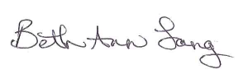Sincerely,

Beth Ann Lang

Director

T.E.A.C.H. MISSOURI

## Glossary of Terms

**Academic probation**—when an “F” is received for any course or when the grade point average with T.E.A.C.H. MISSOURI during a term falls below a 2.0.

**Accessibility stipend**—$55 each semester for Associate, Bachelor, Pre-Certification, and Student Teaching scholarship models.

**Associate degree**—an undergraduate degree awarded by colleges upon completion of a course of study lasting two years.

**Bachelor’s degree**—an undergraduate degree consisting of four years of study, typically requiring a minimum of 120 credit hours of study.

**Bonus**—$150-$450 given by T.E.A.C.H. MISSOURI to a scholarship recipient who has completed their education period with a minimum of 9 completed credit hours (unless the contract minimum stipulates fewer than 9 credit hours for completion). This bonus may or may not include compensation from the sponsor (depending on the scholarship model) and is paid by T.E.A.C.H. MISSOURI in two installments. Bonus amounts are dependent upon the T.E.A.C.H. MISSOURI scholarship model.

**Certification**—state teaching certificate that allows a person to teach in the public school system in Missouri.

**Charge approval**—a letter sent to the college or university stating that T.E.A.C.H. MISSOURI will pay for the tuition. These letters are generally faxed or emailed to the business office at the college or university.

**College advisor**—a counselor at the college or university who is there to help students select appropriate courses based on academic goals.

**Commitment time**—every T.E.A.C.H. MISSOURI Scholarship includes commitment time. After the education period, the employee is committed to remaining with the sponsor or within the early childhood field for 6-12 months. The flexibility and length of the commitment time is dependent upon the T.E.A.C.H. MISSOURI scholarship model.

**Contract**—a contract (Form A) is a legal document that outlines the agreement between you, your employer, and T.E.A.C.H. MISSOURI.

**Copay**—10-15% of tuition and books that is due from sponsors each term courses are taken. The percentage depends on the scholarship model.

**Drop**—when a recipient withdraws from a course without incurring any tuition charges. If tuition has already been paid, the full amount will be refunded. Courses that are dropped do not show up on the student’s college transcript.

**Education period**—this consists of three standard, consecutive college semesters used to complete 9-15 credit hours of coursework for scholarship models. Pre-Certification and Student Teaching models have a shortened education period and different credit hour requirement. You can find the start and end date on the contract.

**Fees**—charges that T.E.A.C.H. MISSOURI does **not** cover. Students are solely responsible for all fees charged by the college or university.

**Financial aid**—money that can be used for higher education and comes in the form of grants, work-study, scholarships, and student loans. Most frequently, people are referring to the FAFSA when inquiring about financial aid. This is a **F**ree **A**pplication for **F**ederal **S**tudent **A**id and can be accessed at [www.fafsa.gov](http://www.fafsa.gov).

**Form A**—legal contract outlining responsibilities and commitment of all parties involved. A signed copy must be returned to T.E.A.C.H. MISSOURI in order for you to become a scholarship sponsor and your employee to become a recipient.

**Form B**—used to claim tuition, accessibility stipend, and books per semester courses are attended. These are mailed to the recipient’s home address as part of the acceptance packet.

**Form C**—used by the sponsor to claim paid time off given to the recipient each semester courses are attended. These are mailed directly to the sponsor as part of the welcome packet for all qualifying scholarship models.

**Grant**—money that does not have to be repaid and can be used for a range of educational expenses.

**Incomplete grade**—when a course is not completed during the semester but can be completed later. Courses with “I” as a grade do not count as completed hours for the contract. Instead, the recipient will owe T.E.A.C.H. MISSOURI for the course and any books that were covered unless the course is completed by the end of the following term.

**Itemized receipt**—a receipt showing a price for each item purchased. Receipts must show a total and a list of books purchased. All receipts **must** be itemized.

**Paid time off**—is paid time away from work to attend courses, study, or attend to personal needs; included in Associate, Bachelor, and Pre-Certification scholarship models.

**Pre-Authorization Request Form**—form used to let us know which courses the recipient will be taking each term. It can be faxed or mailed, or the recipient can call us with the course information.

**Purge date**—this is the date set by the college or university when tuition must be paid. If tuition is not paid by the purge date, or courses are not held by a charge approval, the college will drop the courses from their registration database.

**Recipient**—your employee who is receiving a T.E.A.C.H. MISSOURI Scholarship.

**Release time**—is paid time off. This terminology still appears in contracts, so it might be familiar to existing recipients and directors. For the purpose of this handbook, we will refer to release time as paid time off.

**Registration**—enrolling in a college course as a student.

**Scholarship**—support for a student’s education.

**Scholarship Counselor**—your Counselor is a specific individual who is assigned to work with you and your recipient during the contract. This is the person you should ask for when calling our office. Your counselor can assist you with questions about the scholarship, questions or concerns about courses, and maximizing your T.E.A.C.H. MISSOURI benefits. Contact your counselor at least once per semester.

**Student loan**—student aid funds that must be repaid with interest. There are both subsidized and unsubsidized student loans. Speak with a Financial Advisor at the college or university for more information.

**T.E.A.C.H.**—**T**eacher **E**ducation **a**nd **C**ompensation **H**elps, a national scholarship and compensation project.

**Term**—semester of college courses.

**Withdrawn**—when a recipient withdraws from a course without getting a full refund of tuition. Withdrawn courses usually, but do not always, show up on a student’s transcript with a “W”, “WP”, or “WF” grade and may negatively affect a student’s GPA. The recipient must repay T.E.A.C.H. MISSOURI any tuition and book costs that we covered for a withdrawn course.

## Confidentiality

T.E.A.C.H. MISSOURI agrees to respect and maintain confidentiality of all personal information. T.E.A.C.H. MISSOURI does not sell personal information. Aggregate data for reporting is shared. Communication between recipients, sponsors, and T.E.A.C.H. MISSOURI may also be shared with funders of the scholarships and be used to determine continuing scholarship eligibility. Email addresses of recipients and sponsors are used to communicate scholarship related information, as well as, opportunities to advocate for early childhood programs and T.E.A.C.H. MISSOURI. In addition, information is shared with colleges or universities to verify enrollment and to facilitate T.E.A.C.H. MISSOURI tuition payments.

## Forms and Instructions

In this section…

* **Form A**
* **Form B**
* **Form C**
* **Pre-Authorization Request Form**

### Form A

Form A must be signed and returned to T.E.A.C.H. MISSOURI in order for any payments or reimbursements to be processed. A signed Form A may be faxed to T.E.A.C.H. MISSOURI to expedite a charge approval. However, an original signed form must be mailed to T.E.A.C.H. MISSOURI.

It should be noted that the contract specifies that Child Care Aware® of Missouri is one of the parties agreeing to the contract. Child Care Aware® of Missouri is the parent organization for T.E.A.C.H. MISSOURI and is the business name for the Missouri Child Care Resource and Referral Network.

### Form B

Form B needs to be completed and turned in by the recipient each semester the recipient is enrolled in college courses for their T.E.A.C.H. MISSOURI Scholarship. It is used to claim book and tuition payments. It is also used to process the accessibility stipend if the scholarship model includes it.

The form has three sections. The top portion of the form has information about the recipient and program. Recipients should verify that the information is correct. (See the figure.)

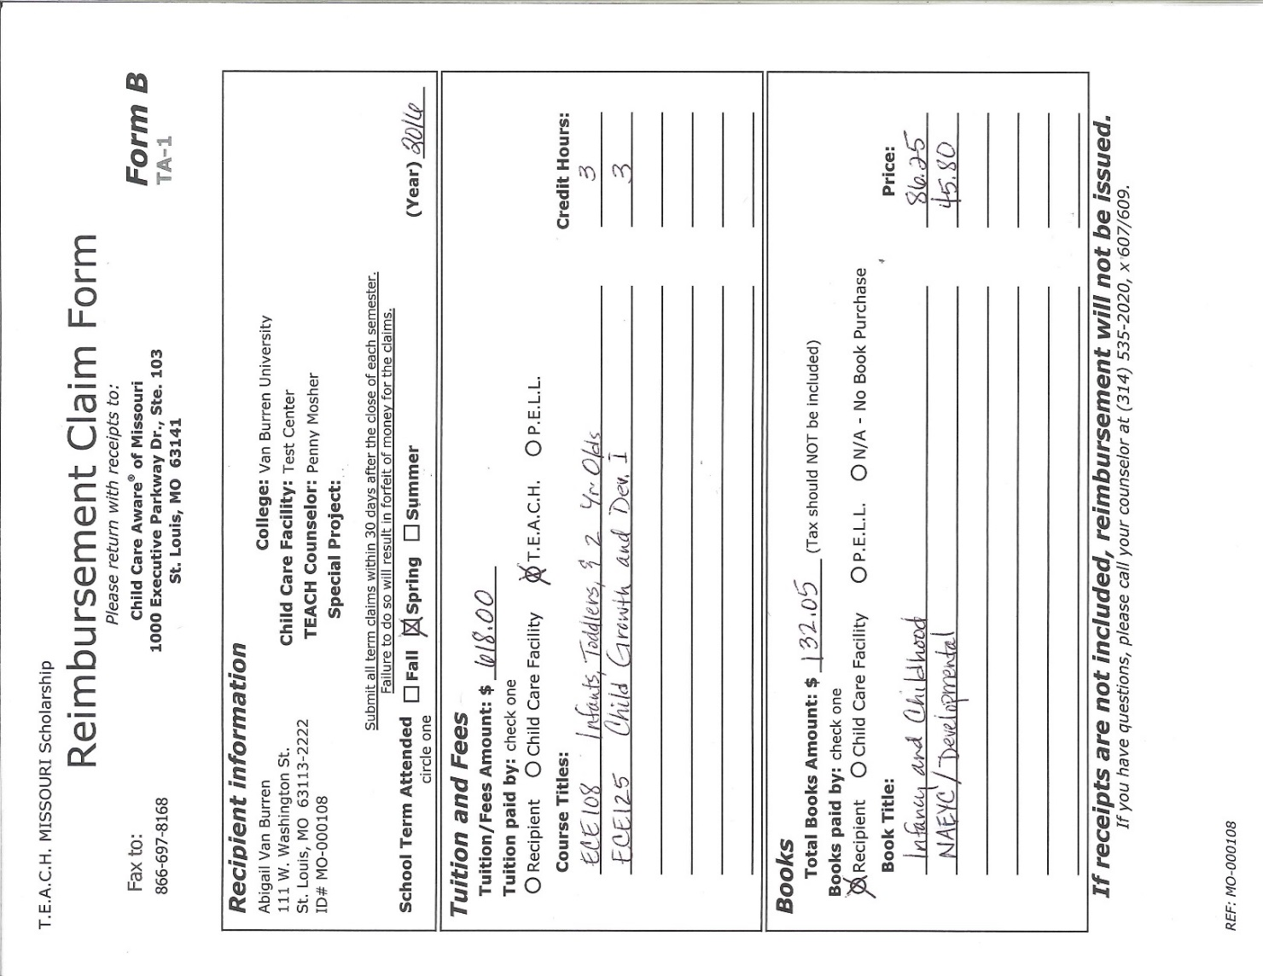

Indicate the term and year

The middle portion of the form is for information about tuition. Even if T.E.A.C.H. MISSOURI pays tuition directly to the college or university, the section must be completed. For more information about how to complete the middle section of Form B, see Tuition under the Procedures section in this Handbook.

The bottom portion of the form is for claiming any book purchases. For information about how to properly complete this section of the form, see Books in the Procedures section.

To process claims for tuition paid or books purchased by a recipient or sponsor, receipts must be included. In addition, receipts must be itemized. All tuition receipts must indicate that there is a zero balance on the student’s account or show payments that are at least equal to the claim amount. Book receipts must show the title of the book and need to show that the balance of the books is zero. For an example of a completed Form B with sample receipts, see Appendix A. Since Form Bs are mailed directly to the recipient, if a sponsor has paid tuition or covered the cost of books and does not have a Form B, onecan be requested from T.E.A.C.H. MISSOURI.

### Form C

Form C is used to claim paid time off. Copies of the form are mailed to the *sponsor* at the start of each contract for qualifying models. (Entry Associate and Student Teaching scholarships do not include paid time off.) If you have a recipient with an Associate, Bachelor, or Pre-Certification scholarship model, paid time off is **required** in the contract. However, it is up to you and your recipient to determine how, when, and in what increments paid time off is used. Contractually, Bachelor and Pre-Certification scholarship recipients take 2 hours of paid time off each week of courses, and Associate scholarship recipients take 3 hours per week.

You may complete Form C or you may have your recipient complete it. Either way, please ensure that it is completely filled out. (See the example in Appendix B for a sample of a completed Form C.) Paid time off cannot be claimed unless the form is signed by you and your recipient. When you and the recipient sign Form C, you confirm that the information is accurate. Do not sign or send the form if the information is inaccurate. Let a Scholarship Counselor know if you are having problems scheduling the required paid time off.

Reimbursement for paid time off **is paid to the sponsor** if the amount claimed exceeds the amount of the sponsor’s balance. Claim amounts for paid time off are $10.00 per hour for all scholarship contracts beginning January 1, 2016 or later. Recipients only receive reimbursement for paid time off if they are the owner of a family child care. All other reimbursement checks for paid time off are made out to the sponsor.

### Pre-Authorization Request Form

Copies of the Pre-Authorization Request Form are mailed to the recipient with the acceptance packet. This form serves one purpose: it lets T.E.A.C.H. MISSOURI know which courses will be taken. If the recipient calls the office and gives course information to a Scholarship Counselor, then submitting a Pre-Authorization Request is unnecessary. However, if the form is completed and faxed or mailed to T.E.A.C.H. MISSOURI, the recipient should retain a copy for their records. As soon as we receive the Pre-Authorization Request and see a requested charge approval, we will input the course information and send a letter to the college. For an example showing a completed Pre-Authorization Request Form, see Appendix C.

## Procedures

In this section…

* **Contract Acceptance**
* **Registering for Courses**
* **Getting a Charge Approval**
* **Tuition**
* **Books**
* **Accessibility Stipend**
* **Paid Time Off**
* **Adding, Dropping, and Withdrawing from a Course**
* **Grades**
* **Academic Probation**
* **Student** Teaching
* **Pre-Certification**
* **Evaluations**

### Contract Acceptance

Once an applicant is approved for a scholarship, an acceptance packet is mailed to their home address. The acceptance packet includes a letter, Pre-Authorization Requests, Form As, Form Bs, and instructions. The sponsor also receives a welcome letter and Form Cs if appropriate. Once the applicant provides you with the contract, read it carefully. By signing a contract, the recipient and sponsor are accepting all terms described in the contract. To accept the scholarship and make it active, T.E.A.C.H. MISSOURI must receive Form A with the applicant’s and sponsor’s signatures. Only when the signed contract is returned to T.E.A.C.H. MISSOURI are you considered a scholarship sponsor. No charge approvals or reimbursements can be processed until the signed contract is received. Additionally, the Acknowledgement of Receipt of Sponsor Handbook must also be received from the sponsor.

Although contracts can be faxed to T.E.A.C.H. MISSOURI to expedite charge approvals, **one original must be mailed to the office for auditing purposes.**

By signing the contract, the sponsor is agreeing to:

* Reimburse T.E.A.C.H. MISSOURI 10% to 15% of the cost of tuition and books, depending on scholarship model and option
* Complete and submit all forms in a timely manner
* Retain the recipient as an employee working at least 30 hours per week during the education period and commitment time (as applicable)
* Provide T.E.A.C.H. MISSOURI with program information as requested
* Award a bonus or provide a raise as stipulated in the contract.

### Registering for Courses

The process of registering for courses varies by college, and as a sponsor, you can help facilitate that process by familiarizing yourself with general college processes and policies. If a recipient has not taken college courses, or has not taken courses recently, the first step is to apply for admission to the institution. (Admission fees are not covered by T.E.A.C.H. MISSOURI.) In addition, many institutions encourage students to apply for financial aid. To maximize T.E.A.C.H. MISSOURI funding, all scholarship recipients enrolled in courses after June 2014 are required to apply for federal student aid. (For additional information about applying for federal student aid, please refer to the Financial Aid section.)

Before registering each semester, it is very important that the sponsoring program director meet with the recipient to discuss potential course schedules. This will help the director plan for the paid time off if a recipient is eligible and arrange coverage for the classroom while the recipient is using the paid time off.

Once a recipient is accepted to an institution, it may be necessary to take placement exams. If this is the case, T.E.A.C.H. MISSOURI cannot pay for any placement exam fees. However, if a recipient has an Entry Associate Scholarship, T.E.A.C.H. MISSOURI may pay for one general education course if the course is required before enrollment in early childhood or early childhood special education courses is permitted. This exception is permitted on a case-by-case basis. Consult with a Scholarship Counselor if this is the case for one of your recipients. If T.E.A.C.H. MISSOURI cannot cover a pre-requisite general education course, the recipient will be responsible for all costs associated with the course(s).

The first term in a contract is limited to 3-6 credit hours. Approval for more credit hours requires special approval and may require additional documentation. Approval of an appropriate course load is always at the discretion of the Scholarship Counselor.

As a sponsor, you want to ensure that recipients are registering for courses that are required for their certification or degree program. At the same time, accreditation requirements may necessitate specific courses. To balance these needs, it is best for the recipient to meet with a College Advisor. Colleges and universities assign an advisor to new students, but if a recipient does not have an advisor, it is their responsibility to contact the college or university to seek advisement regarding course selection.

Many institutions have very rigid policies surrounding registration. Current students register before new students, and some schools restrict registration based on previous credit hours completed. For more information about Missouri-based colleges, see the online [T.E.A.C.H. MISSOURI College Directory](http://teach-missouri.org/college-directory/). Encourage the recipient to check the college or university website for deadlines and guidelines about registering for courses. Once a recipient has registered for courses, arrangements need to be made to pay tuition. The recipient or sponsor can either pay the tuition and submit applicable receipts with Form B or request a charge approval.

All scholarship models support early childhood and early childhood special education courses. Associate, Bachelor, Pre-Certification, and Student Teaching models also support general education. If in doubt about whether a course can be claimed, please have the recipient call and confirm with a Scholarship Counselor **prior** to registering for the course.

### Getting a Charge Approval

If a recipient would like to have T.E.A.C.H. MISSOURI pay tuition to the college or university, a charge approval must be arranged. Recipients can call and request a charge approval or submit a Pre-Authorization Request Form. If there is any doubt about whether a charge approval can be sent for a recipient, please have the recipient call prior to registering for the course. T.E.A.C.H. MISSOURI is able to process charge approvals for all Missouri-based public colleges. Please call a Scholarship Counselor with questions about charge approvals for private colleges.

### Tuition

Tuition is claimed using Form B. To claim tuition paid by a sponsor or recipient, the form must be complete and include receipts showing the tuition amount and a balance of zero. Please refer to the Recipient Handbook for more detailed instructions about submitting a claim for tuition. See Appendix A for an example of a completed Form B with sample receipts.

### Books

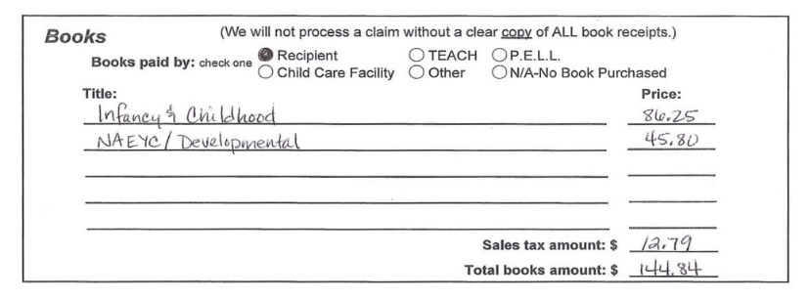

bottom section of Form b

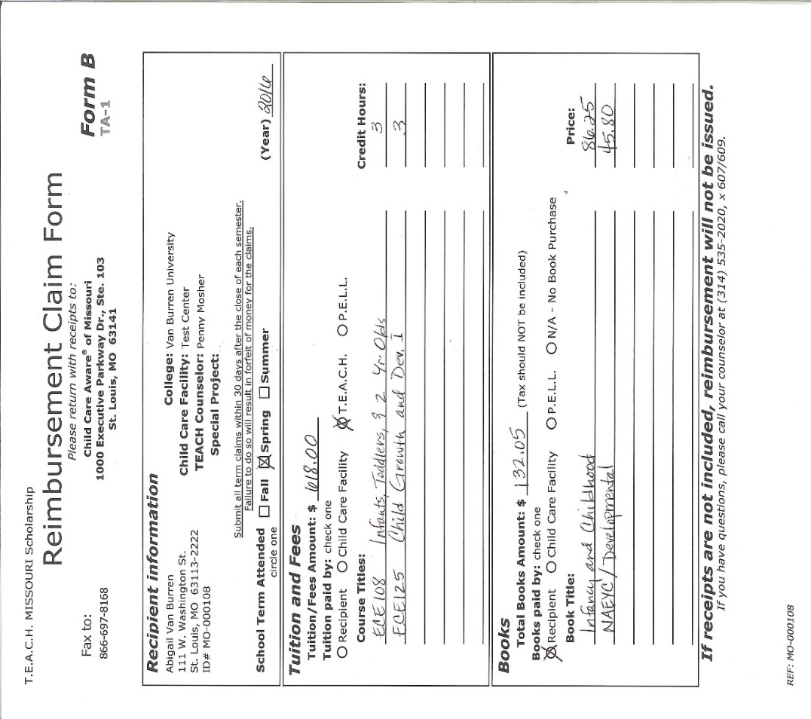

middle section of form b

Books can also be claimed using Form B. The bottom portion of the form allows the recipient to specify who purchased the books, how much they cost, and the book titles. (See the figure.) Please refer to the Recipient Handbook for more detailed instructions about submitting a claim for books. For an example of book receipts, see Appendix A.

### Accessibility Stipend

The accessibility stipend is available for Associate, Bachelor, Pre-Certification, and Student Teaching scholarship recipients. Every semester a student attends courses, they will receive a $55 credit to their T.E.A.C.H. MISSOURI account. It is processed when the Form B for the semester is processed and occurs after T.E.A.C.H. MISSOURI has been billed for tuition.

### Paid Time Off

Paid time off is claimed using Form C. Copies of this form are mailed to the sponsor when a scholarship offer requiring paid time off is approved. The director and recipient should schedule and track paid time off, and both must verify the hours on the form by signing on the lines specified. (See the figure below.) No additional documentation is required from the sponsor to process the Form C. However, a recipient’s Form B must be in the system prior to a Form C being processed for the term, and if tuition is being paid by T.E.A.C.H. MISSOURI, a tuition bill must have been received from the college.

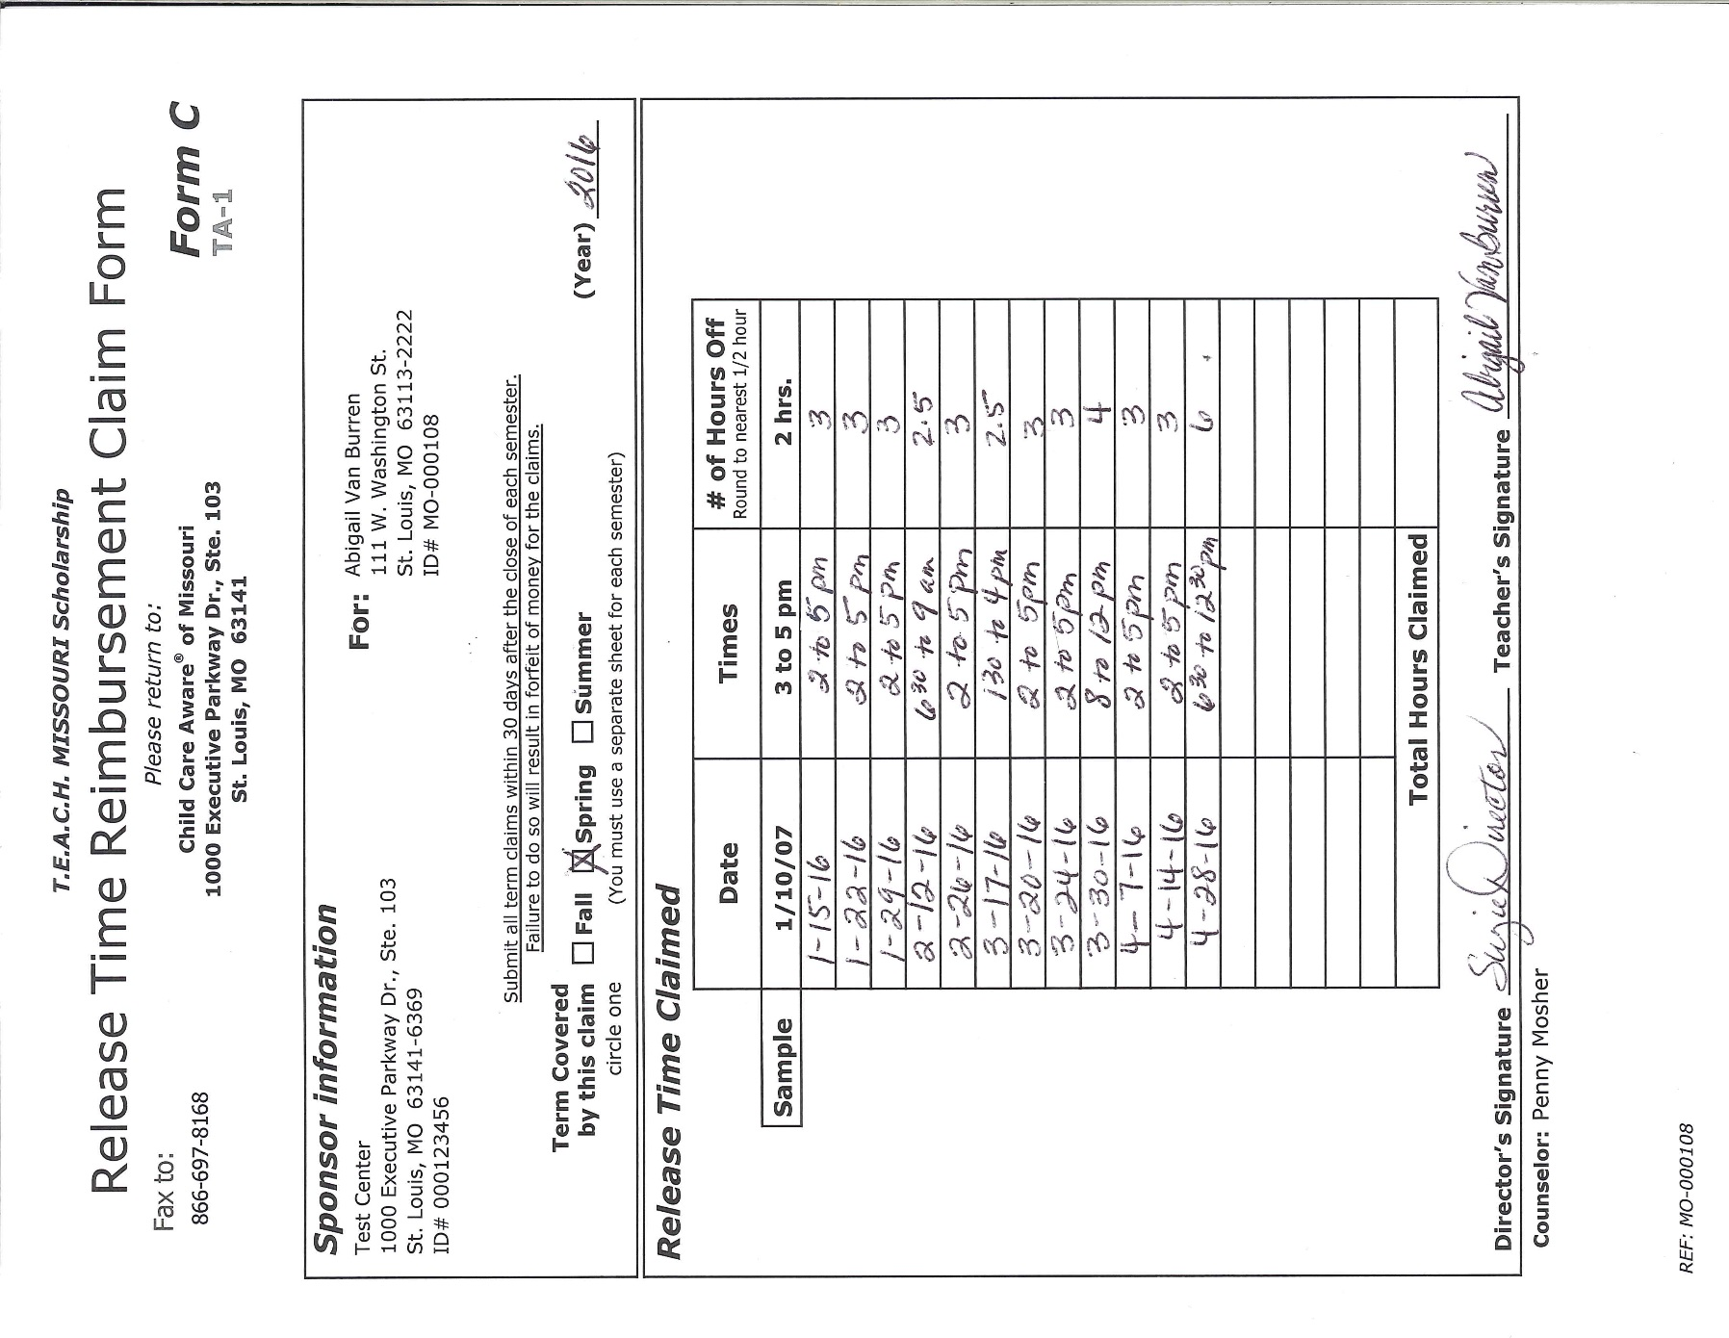

39

bottom of form c

If the program is closed during the summer semester, a recipient is not eligible for paid time off. Also note that paid time off cannot be used during school breaks unless assignments are due. It is anticipated that sponsors only provide the paid time off during weeks when the recipient is actually attending classes or when assignments are due.

Some paid time off examples:

* The course meets during the day while children are at the program; you may provide paid time off for the hours the recipient attends the course.
* A study group for the course is meeting during the day while children are at the program; you may provide paid time off for the hours when the recipient attends.
* You provide paid lunch breaks and the recipient uses the time to study or attend to personal needs.
* You work out a schedule with the recipient that allows them to leave early from, or arrive late to, work. You pay the recipient as if on a normal schedule.

### Adding, Dropping, and Withdrawing from a Course

It is the responsibility of the scholarship recipient to notify T.E.A.C.H. MISSOURI if a course is added, dropped, or withdrawn during the term. However, as a sponsor, we ask that you update us if your recipient is struggling with courses or if their performance at work declines due to the increased stress of coursework. The best way to do this is by calling a Scholarship Counselor and discussing a possible course of action to improve the situation. Early detection of potential issues can help all parties involved enjoy success.

Colleges may not automatically drop a student for failure to attend. Please be mindful of applicable college dates and deadlines and encourage recipients to *officially* drop courses if necessary.

|  |  |
| --- | --- |
| **What if a recipient drops, withdraws, or fails a course?** | |
| Failed Course  (Grade of “F”) | No financial penalty from T.E.A.C.H. MISSOURI unless the minimum credits for the contract is not reached, but T.E.A.C.H. MISSOURI is unable to pay for the course a second time. Paid time off can still be claimed for applicable contracts as long as the recipient continued to attend the course. |
| Dropped Course  after the 100% refund date | Scholarship recipient repays T.E.A.C.H. MISSOURI for any tuition paid. T.E.A.C.H. MISSOURI is unable to pay for the course a second time. Paid time off can only be claimed for applicable contracts if the recipient is completing other courses for the same term. |
| Withdrawn Course | Scholarship recipient repays T.E.A.C.H. MISSOURI for any tuition paid. T.E.A.C.H. MISSOURI is unable to pay for the course a second time. Paid time off can still be claimed for applicable contracts as long as the recipient continued to attend the course. |

### Grades

Recipients are required to mail, fax, or email grades as soon as the semester ends. Colleges and universities will not send the grade report to T.E.A.C.H. MISSOURI and may not send a paper copy to the student. Failure by a recipient to submit grades can delay claims and possible reimbursements.

Grades may also be obtained from the Registrar or Records Office at the college or frequently from the recipient’s student account. There may be a charge for getting an official transcript, so encourage your recipient to ask if unofficial transcripts are available for free.

#### What happens if a recipient fails a course?

T.E.A.C.H. MISSOURI understands that situations may arise that affect the ability of a scholarship recipient to pass a course. In lieu of this, T.E.A.C.H. MISSOURI will pay once for a course that was failed. However, the scholarship recipient pays for the tuition and associated costs of retaking the course.

Note: Each college determines what makes up a failing grade for general education and early childhood courses. Some courses must have a grade of a “C” or better while other departments may accept a lower grade. Encourage your recipient to contact a college advisor for more information.

If a recipient does not achieve the college’s minimum required grade and cannot continue in her/his degree program, T.E.A.C.H. MISSOURI cannot pay for any attempts to retake the course.

### Academic Probation

A recipient will be placed on academic probation with the T.E.A.C.H. MISSOURI Scholarship for the following term if, during the term the student fails a course or does not earn a term GPA of 2.0 or higher.

* A recipient on academic probation must earn a grade of *C* or better on courses taken within their scholarship contract.
* A recipient on academic probation will be restored to good academic standing the following term if a term GPA of 2.0 or higher is earned.
* Recipients on academic probation will be required to speak with a Scholarship Counselor at the beginning of the probationary period and complete an Academic Probation Acknowledgement Form.
* A recipient on academic probation will be required to secure prior approval for courses to be taken each semester and will be prohibited from taking more than 3 credit hours during the probationary term.

### Student Teaching

If a recipient will be student teaching, this is a special situation that requires additional documentation and a special scholarship model. The student teaching model covers 8-15 credit hours of early childhood, early childhood special education, or general education courses during one semester. Although the recipient does qualify for an accessibility stipend, there is no paid time off for this scholarship model. The work requirement during the education period is also adjusted. A recipient must work 5 hours per week at the sponsoring program while student teaching. The sponsoring program must provide additional compensation, and during commitment time, which is 3 consecutive months for this type of scholarship, the work requirement returns to 30 hours per week. Please ensure that the Form A for any recipient doing student teaching indicates a Student Teaching model.

### Pre-Certification

If a recipient only has 1 or 2 semesters remaining before student teaching will begin, a Pre-Certification scholarship might be the best option. These scholarship models cover 9-15 credit hours of early childhood, early childhood special education, or general education courses during one or two semesters. Although the recipient does qualify for an accessibility stipend and paid time off, the compensation from the sponsoring program is not optional. Please ensure that the Form A indicates a Pre-Certification model if appropriate.

### Evaluations

Each year, T.E.A.C.H. MISSOURI requests feedback from scholarship recipients and sponsors regarding the program and its impact. This feedback, frequently referred to as an annual survey or annual evaluation, provides T.E.A.C.H. MISSOURI with data used to compile our annual report. The data used is aggregated to inform current and potential funders of T.E.A.C.H. MISSOURI about program successes.

The evaluation will be delivered by email for sponsors who have an email address on file. However, sponsors have the option of completing a paper evaluation by requesting one from T.E.A.C.H. MISSOURI. Paper evaluations are available by mail or fax and can be remitted by the same.

## Financial Information

In this section…

* **Financial Aid**
* **Invoices**
* **Reimbursements**
* **Tax Information**

When forms, receipts, and applicable bills have been received, a Scholarship Counselor will process all claims and prepare applicable reimbursements and invoices. If a charge approval is sent for the courses, Form B and Form C will not be processed until a tuition bill from the college is received. This means that if the sponsor purchased books for the recipient, that claim will not be processed until after a tuition bill has been received by T.E.A.C.H. MISSOURI. Courses listed on the form are matched to those on the college bill and corresponding books are matched to each course. This also allows T.E.A.C.H. MISSOURI to know the appropriate tuition copay amount.

### Financial Aid

It is a requirement that all scholarship recipients *apply* for federal aid through the Free Application for Federal Student Aid (FAFSA). Per regulations, any federal aid received by a recipient must be applied to the recipient’s account prior to the use of T.E.A.C.H. MISSOURI funds. Because of this, it is T.E.A.C.H. MISSOURI’s policy to wrap around federal funding received. Recipients need to reapply through the FAFSA each year. The best time to do this is in the spring as soon as federal income taxes are filed. Contracts may be withdrawn when a recipient has not applied for federal aid or if federal aid is not accepted when awarded. In order to confirm completion of the FAFSA, recipients must provide a copy of the Student Aid Report (SAR). As a sponsor, you can facilitate this process by encouraging your recipient to be diligent to complete the FAFSA process. T.E.A.C.H. MISSOURI **cannot** cover any tuition or process any claims for books, paid time off, or the accessibility stipend after completion of the first semester if we have not received the FAFSA SAR.

### Invoices

If the total owed for tuition and book copays exceeds the amount claimed, an invoice will be processed for the difference. You will have 60 days to pay the invoice. A second notice will be sent if no payment has been received after 60 days, and you will have an additional 30 days to pay the invoice. A final notice will be sent if you still have not paid the invoice. If no payments are received for the invoice 30 days after the final notice or other payment arrangements have not been made, the account may be turned over to a collection agency. The contract will be withdrawn and you will not receive any further reimbursements from T.E.A.C.H. MISSOURI or be eligible to sponsor a recipient until the invoice is paid. Please do not hesitate to contact T.E.A.C.H. MISSOURI if you feel there is an error in billing or if you have difficulty paying an invoice. For a sample invoice calculation, see Appendix E.

### Reimbursements

If the total owed for tuition and book copays is less than the amount you claim, you will be reimbursed by T.E.A.C.H. MISSOURI. Typical processing time for reimbursements is 4-6 weeks. Every effort is made to provide reimbursements in a timely manner. However, Form C processing does not take place until after a college bill has been received for any recipient using a charge approval to hold courses. Additionally, Form B must be received prior to processing Form C. This may mean that claims are not processed until mid-term or later depending on the college and the recipient. If you have concerns regarding a reimbursement, please contact our office. For a sample calculation of a reimbursement, see Appendix F.

### Tax Information

When you receive the welcome letter from T.E.A.C.H. MISSOURI, you will also receive a copy of a W-9. ***Before any reimbursements or payments can be made to the sponsor, this form must be completed and on file with our accounting department.*** The W-9 can be sent back when the signed contract is mailed back, or it can be faxed to T.E.A.C.H. MISSOURI.

All sponsors should report taxable funds received from T.E.A.C.H. MISSOURI on tax filings. Sponsors who receive more than $600 in taxable funds during a calendar year will receive a 1099 from Child Care Aware® of Missouri. Some educational expenses can be deducted on tax filings. Please consult your tax professional if you have questions regarding these tax deductions.

## Completing a Contract

In this section…

* **Compensation**
* **Commitment TimeCONTRACT** RENEWAL
* **Information Updates**
* **Graduates**

### Compensation

Compensation is a tenet of T.E.A.C.H. MISSOURI. All contracts include, upon successful completion of the education period, additional compensation. This includes a bonus and sometimes a raise. Each of these options is outlined below. The option selected was chosen during the application process on the Center Participation Agreement. To determine which option was chosen, please refer to Form A or contact T.E.A.C.H. MISSOURI.

#### Bonus

Each scholarship recipient who completes a contract is eligible to receive a bonus from T.E.A.C.H. MISSOURI. This bonus is awarded in two installments. The first half of the bonus is processed upon the successful completion of the education period. This requires that all paperwork, including grades, claim forms, and graduation documentation, be submitted to the T.E.A.C.H. MISSOURI office. All invoices for the contract must also be paid. Recipients are eligible for the second bonus six months later. T.E.A.C.H. MISSOURI will pay bonuses to owners in the same manner.

All scholarships allow the sponsoring employer to match the bonus. If the sponsor agrees to match the bonus, a letter will be sent to you stating that it is time to pay the bonus. The sponsor is asked to provide proof that the bonus is paid. However, if unable to provide the bonus after being notified, please contact a Scholarship Counselor.

#### Raise

All scholarship models include a compensation option. The Associate degree model allow a sponsoring employer to provide a bonus or provide a raise. If you agree to provide a raise, a letter will be sent to you indicating that the 2% raise should be provided. The sponsor is asked to provide proof that the raise has gone into effect with a copy of the check or paystub. However, if unable to provide the raise within 2 pay periods of being notified, please contact a Scholarship Counselor.

### Commitment Time

A key component of the scholarship program is the commitment time. This is a length of time following completion of the education period in which the recipient is committed to employment with the sponsoring program or with a licensed program. This is how T.E.A.C.H. MISSOURI reduces turnover. Commitment time varies in length depending on the scholarship model.

|  |  |  |
| --- | --- | --- |
| **Model** | **Commitment Time** | **Stipulations** |
| Entry Associate | 6 consecutive months  (total contract length of 18 months) | If the sponsoring program provides a bonus, commitment time must be completed with the sponsor. If the bonus option is not selected, a recipient may complete commitment time at any licensed child care program in Missouri. |
| Associate | 12 consecutive months  (total contract length of 24 months) | A recipient must complete commitment time with the sponsoring employer. |
| Bachelor | 9 consecutive months  (total contract length of 21 months) | If the sponsoring program provides a bonus, commitment time must be completed with the sponsor. If the bonus option is not selected, a recipient may complete commitment time at any licensed child care program in Missouri. |
| Pre-Certification 1 | 6 consecutive months  (total contract length varies) | A recipient must complete commitment time with the sponsoring employer. |
| Pre-Certification 2 | 6 consecutive months  (total contract length varies) | A recipient must complete commitment time with the sponsoring employer. |
| Student Teaching | 3 consecutive months  (total contract length varies) | A recipient must complete commitment time with the sponsoring employer. |

In order to complete commitment time, a recipient must continue to work at least 30 hours per week. In addition, recipients that are also owners of the program (including a family child care program) must maintain the licensed status of the program throughout commitment time.

*CONTRACT RENEWAL*

Upon successful completion of an education period, a recipient may be eligible for a renewal contract. This is determined by several factors, including available funding and funder requirements. Renewal contracts are processed through the T.E.A.C.H. MISSOURI renewal list. A recipient **must** contact a Scholarship Counselor prior to the end of the final semester of the education period to be added to the renewal list. T.E.A.C.H. MISSOURI maintains an ongoing waiting list, and new recipients are added each semester as funding allows. A recipient that does not notify T.E.A.C.H. MISSOURI about a renewal is at risk of losing funding for subsequent contracts. If you have recipients that you know will be continuing to take courses, please have them contact a Scholarship Counselor!

Renewal contracts do not require new application materials unless:

* It has been over a year since completing the most recent education period.
* The sponsor has not submitted an updated Program Information Form in over 6 months.
* The sponsoring employer changes.

### Information Updates

Throughout the course of the education period and the commitment time, a Scholarship Counselor will contact you for updates regarding employment status, academic progress, necessary paperwork requirements, etc. If any information changes during the course of a contract (i.e. recipients move, get married, change schools, etc. or you program location changes or licensed capacity changes), please contact T.E.A.C.H. MISSOURI so that information can be updated in our files. Failure to do so will delay reimbursements, claims, and payments.

A Sponsor Information Update form will be provided with notification of a T.E.A.C.H. MISSOURI bonus being paid. Please complete this form and fax or mail it back to T.E.A.C.H. MISSOURI. Feedback and updated information is very important to us and is used to show our funders the continued need for the scholarship program.

### Graduates

Many T.E.A.C.H. MISSOURI recipients earn Childhood Development Associate (CDA) credentials, 1-Year Proficiency certificates, Associate, and Bachelor’s degrees. If a recipient receives a degree or credential during a T.E.A.C.H. MISSOURI contract (including during the commitment time), please provide to T.E.A.C.H. MISSOURI a copy of the diploma or a transcript showing the degree earned. We also welcome photos from commencement ceremonies and graduation parties, especially if these are celebrated by all staff. It is a pleasure to share these accomplishments.

## Withdrawing from T.E.A.C.H. Missouri

In this section…

* **Recipient** Withdraw
* **Lay-off and Termination**
* **Employment Changes**
* **Special Circumstances**

During the course of the education period or commitment time, circumstances may arise that cause a contract to be terminated. Please read the section below to learn about scholarship contract termination. It is important to know the circumstances under which a recipient must repay T.E.A.C.H. MISSOURI for the amount spent on a contract if the contract is not completed.

### Recipient Withdraw

If a recipient leaves (quits) your program voluntarily during the education period or the commitment time, **T.E.A.C.H. MISSOURI will bill the recipient for the cost of any contracts that are not completed**. This bill will reflect not only what we paid to the recipient, but also what we paid the college and sponsor on the recipient’s behalf. It is important to contact a Scholarship Counselor and let them know if you have a recipient that is struggling with a course or if issues have arisen at the program. This will allow a Scholarship Counselor to help you and the recipient to identify possible strategies for working through the situation without having to default on the contract. The sponsoring program may also expect a recipient to repay additional funds that you contributed to the contract. However, this is not part of the regular T.E.A.C.H. MISSOURI contract and any repayment to you from the recipient should be in accordance with employee policy.

### Lay-off and Termination

If a recipient is laid off or terminated from the sponsoring program for reasons outside their control, T.E.A.C.H. MISSOURI cannot continue to support a scholarship. The current semester may be completed, but no further reimbursements will be made for books, accessibility stipends, or for paid time off. Although T.E.A.C.H. MISSOURI is dedicated to improving early childhood teacher retention, we do not anticipate that sponsoring programs will continue to employee teachers at the expense of program and classroom quality.

### Employment Changes

If a sponsoring program is sold or comes under new management, please contact T.E.A.C.H. MISSOURI right away. The new employer will need to agree to the terms of the original contract and sign a new contract. If the employer does not agree to the terms of a contract, the recipient’s T.E.A.C.H. MISSOURI scholarship will be withdrawn, but the recipient will not be billed.

### Special Circumstances

There are select circumstances under which T.E.A.C.H. MISSOURI might withdraw a contract. These are reviewed on a case-by-case basis with a Scholarship Counselor.

## Contacting T.E.A.C.H. MISSOURI

Contact us with questions you may have. We are here to serve you and advocate for you.

|  |  |  |  |
| --- | --- | --- | --- |
| **Phone:** | 800-200-9017 | **Mail:** | T.E.A.C.H. MISSOURI |
| *or in St. Louis at* | 314-535-2020 |  | 1000 Executive Parkway Dr. |
| **Extensions:** | 620, 609, 607 |  | Suite 103 |
| **Fax:** | 866-697-8168 |  | St. Louis, MO 63141 |
|  |  |  |  |
| **Email:** | [Info@teach-missouri.org](mailto:Info@teach-missouri.org) |  |  |

## 

## Acknowledgement of Receipt of Sponsor Handbook

The Sponsor Handbook contains important information about T.E.A.C.H. MISSOURI. I understand that I should contact T.E.A.C.H. MISSOURI regarding questions I have or ones not answered in the handbook. I have entered into this contractual relationship and understand that T.E.A.C.H. MISSOURI, my recipient, or I can terminate the relationship at will, with or without cause, and with or without advance notice and that penalties may apply.

Since the information, procedures and benefits described are subject to change, revisions to the handbook may occur. All such changes will be communicated through official notices, and I understand that revised information may supersede, modify, or eliminate existing procedures.

I understand that this handbook is neither a contract nor a legally-binding agreement. I have read the handbook, and I understand that I may ask T.E.A.C.H. MISSOURI questions I might have concerning the handbook. I accept the terms of the handbook and understand that it is my responsibility to comply with the procedures in this handbook and any revisions made to it. I further agree that if I remain a part of T.E.A.C.H. MISSOURI following any modifications to the handbook, I accept and agree to such changes.

I have read the Sponsor Handbook on the date listed below. I understand that I am expected to read the entire handbook. Additionally, I will sign two copies of this Acknowledgement of Receipt, retain one copy for myself, and return one copy to T.E.A.C.H. MISSOURI. I understand that this form will be retained in my sponsor file.

|  |  |  |
| --- | --- | --- |
|  |  |  |
| Signature of Director or Owner |  | Date |
|  |  |  |
| Director’s or Owner’s Name – Printed |  |  |
|  |  |  |
| Sponsoring Program Name and DVN |  |  |

## Appendix A—Sample Form B

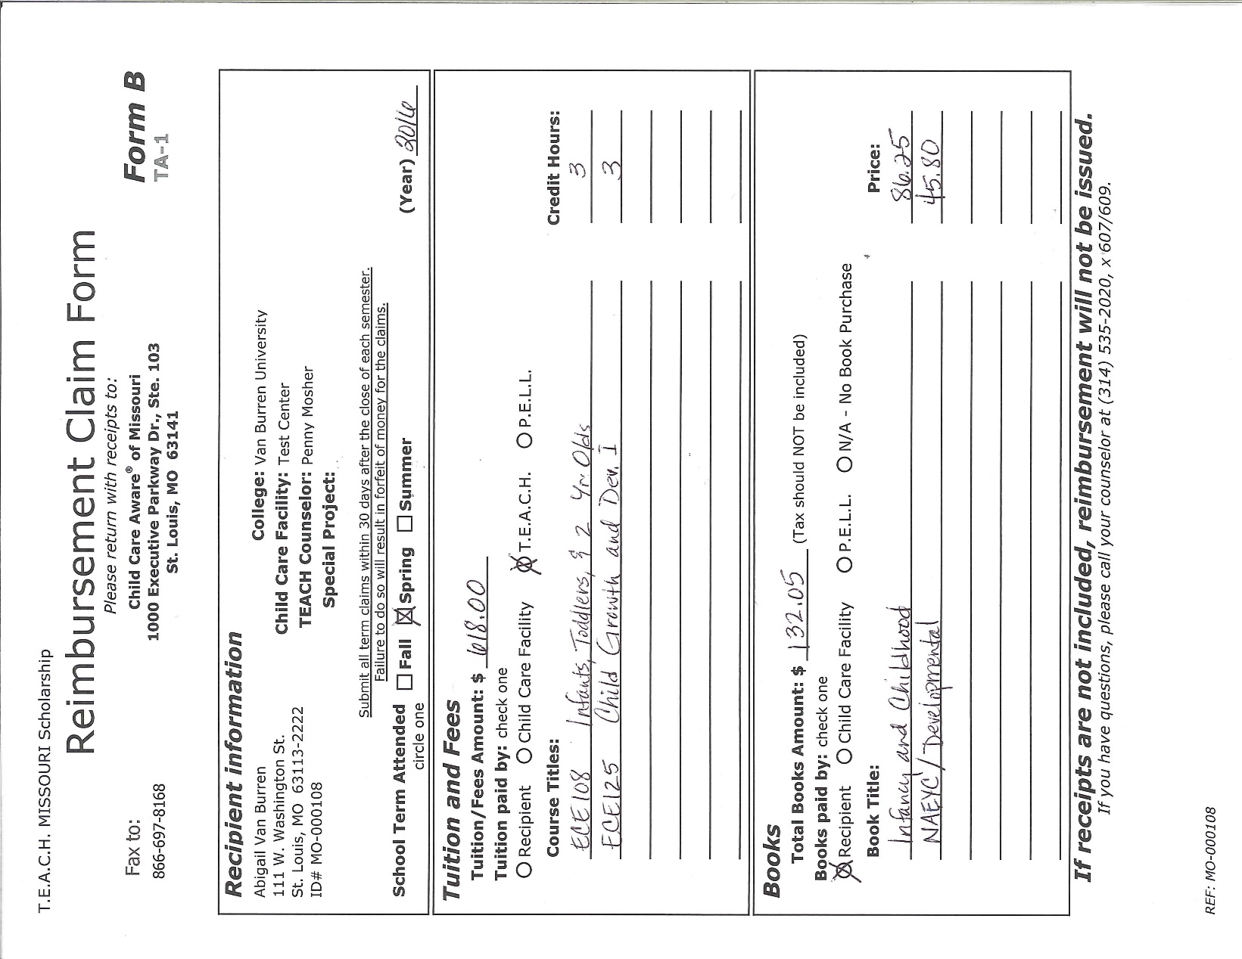Form B will only be used by a sponsoring program if the program purchased books for the recipient.

Total the book amount here.

List textbook titles and amounts.

List **all** courses for the term with course numbers and course titles.

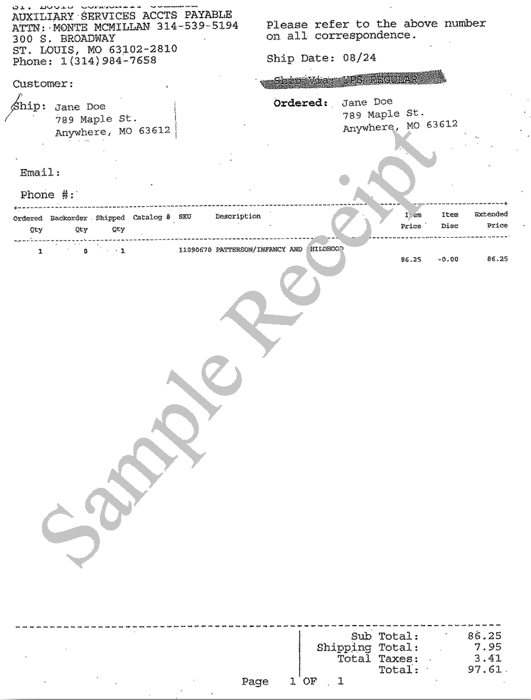

Put the title and unit cost on Form B.

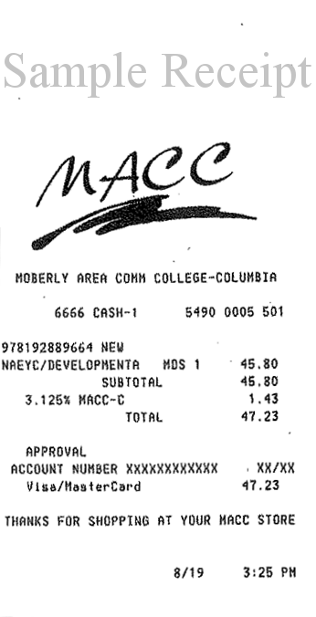

## Appendix B—Sample Form C

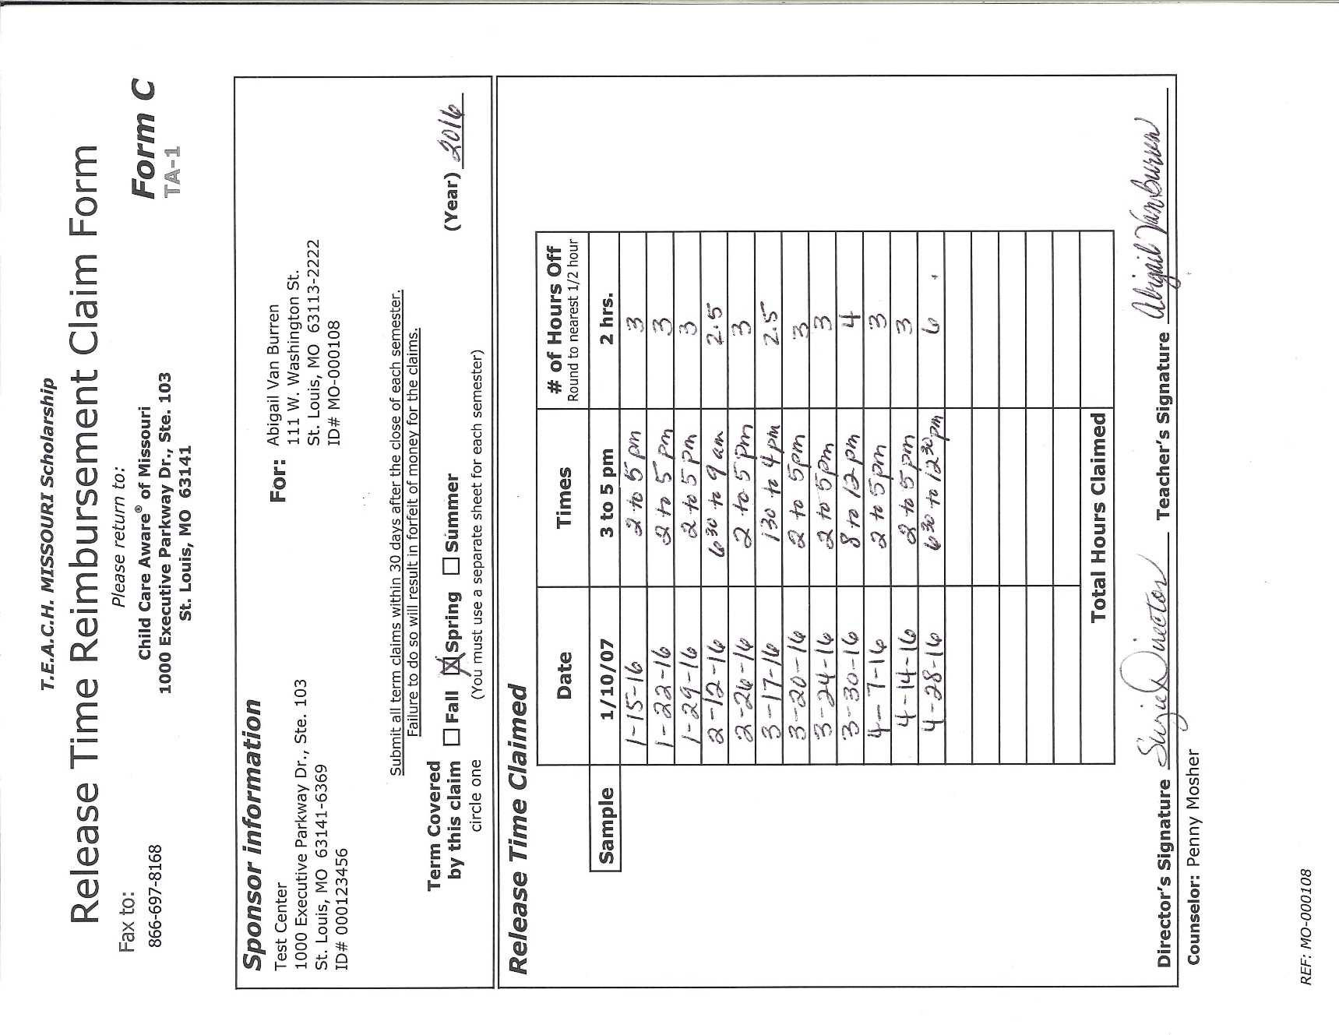

39

## Appendix C—Sample Pre-Authorization Request Form

A Pre-Authorization Request Form will rarely be completed by the sponsoring program. The responsibility for sharing course information with T.E.A.C.H. MISSOURI belongs to the recipient.

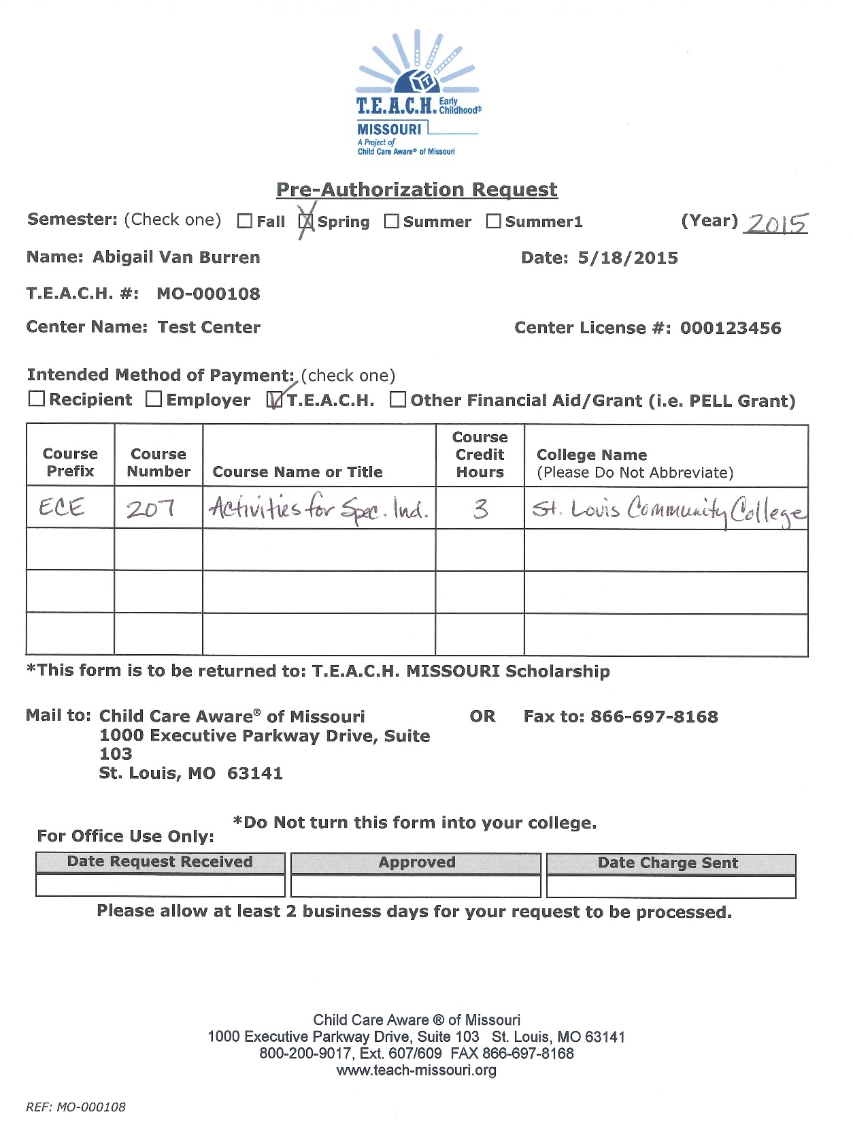

## Appendix D—Sample Invoice Calculation



equals amount sponsor owes

minus

## Appendix E—Sample Reimbursement Calculation



less

is the amount T.E.A.C.H. MISSOURI owes the sponsor

## Appendix F—What Now?

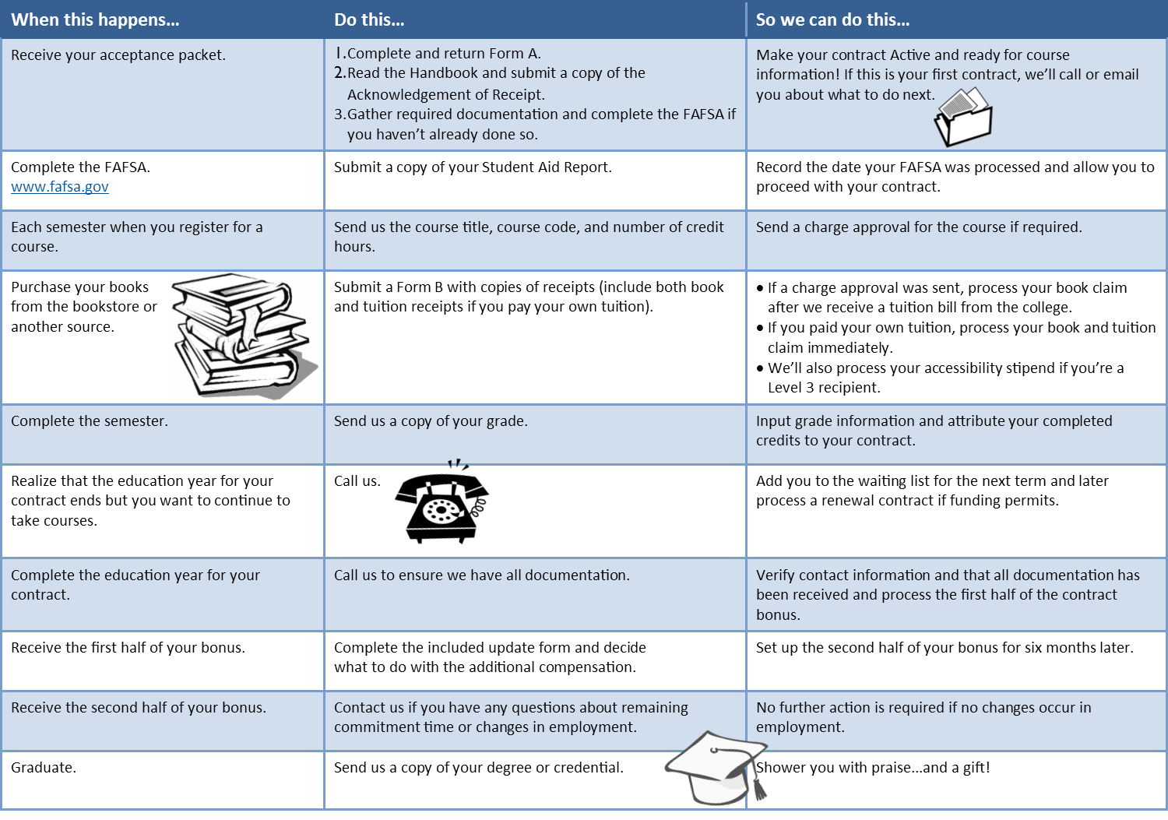An example of actions required by a scholarship recipient.

## Appendix G—Sample Contract Timeline

## Appendix H—Scholarship Model Matrix

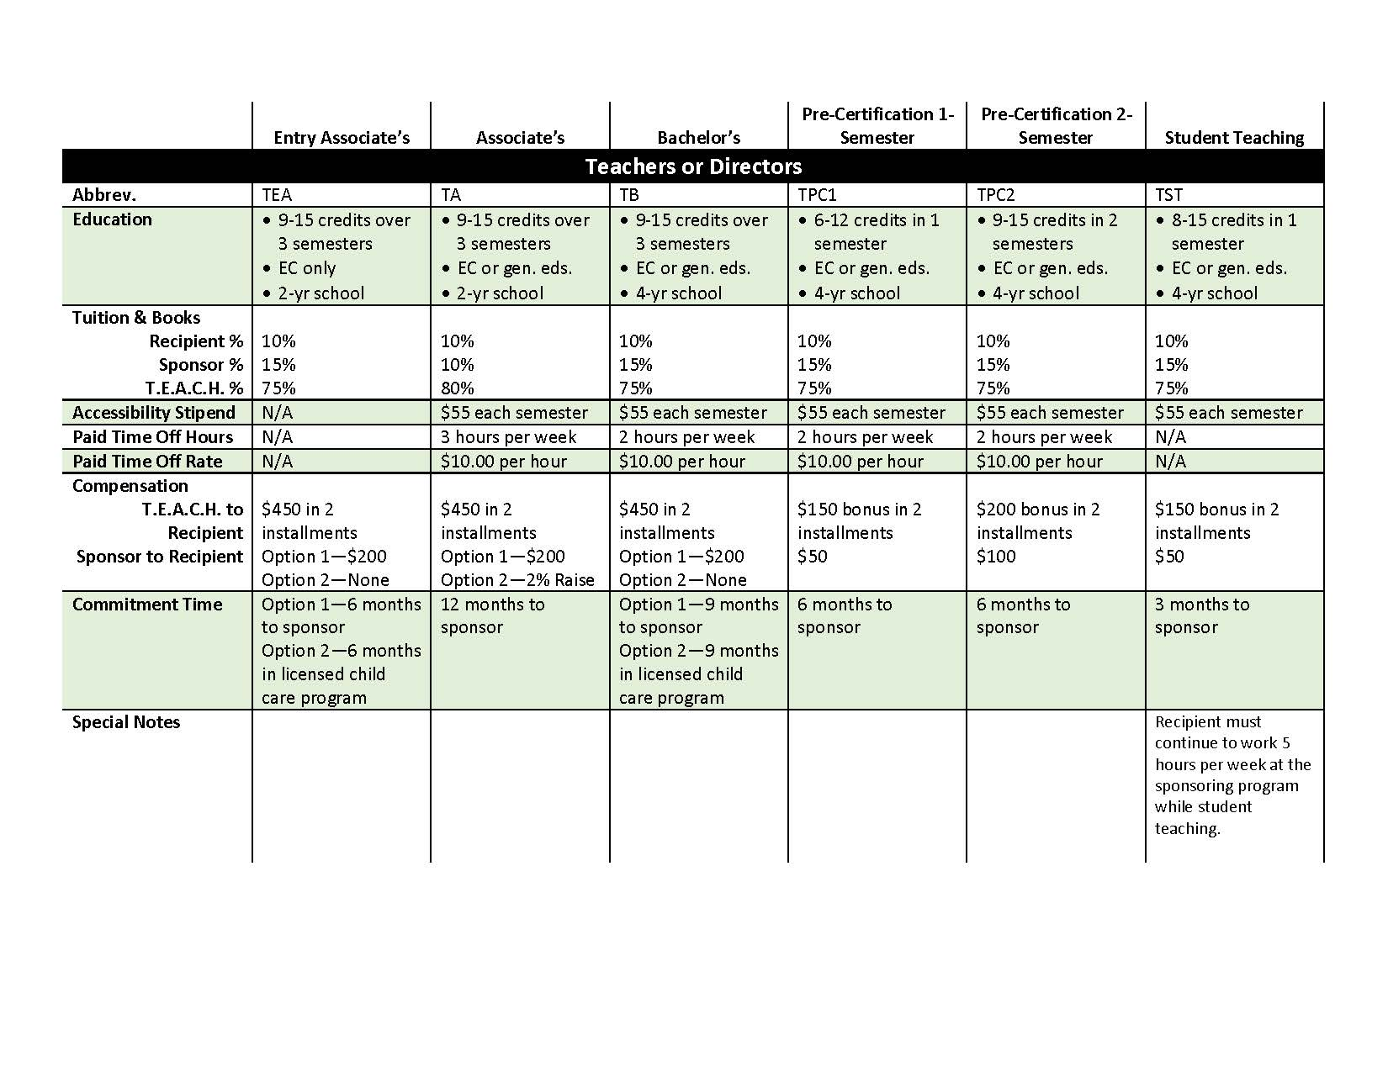

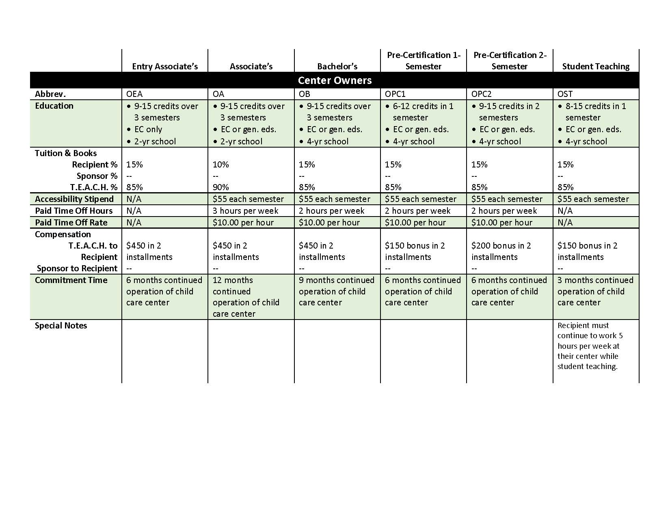

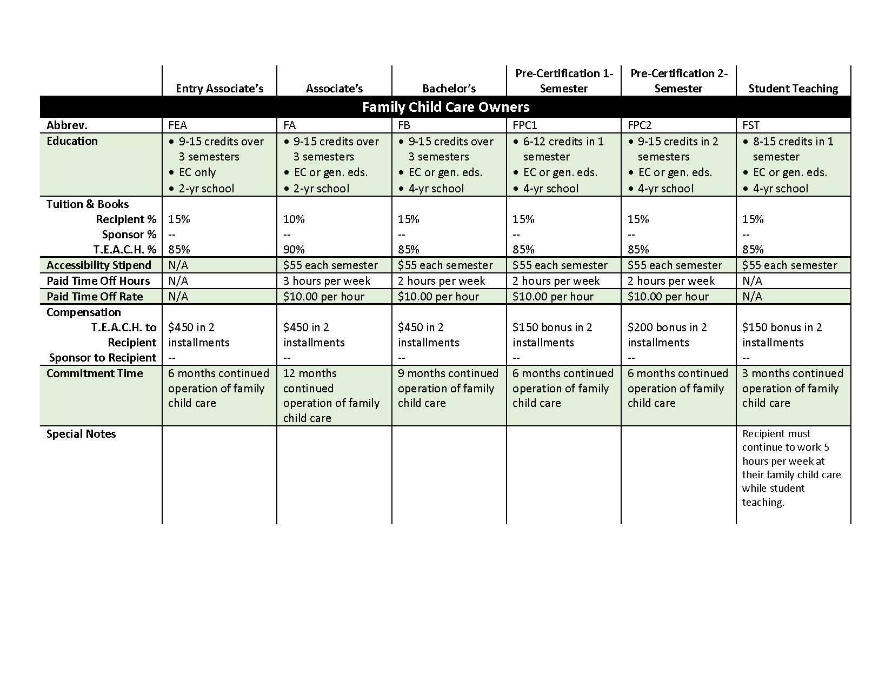

## Index

Academic Probation 5, 13

Acceptance Packet 10

Accessibility stipend 5, 8, 11

Associate degree 5

Bachelor’s degree 5

Bonus 5, 16

Books 8, 11

Certification 5

Charge Approval 5, 11

College advisor 5

Commitment time 5, 16

Compensation 15

Confidentiality 7

Contract 5

Renewal 15, 17

Copay 5

Course

Adding a 9, 12

Dropping a 9, 12

Failing a 13

Withdrawing from a 9, 12

Drop 5

Education period 5

Evaluations 14

FAFSA 5

Fees 5

Financial aid 5, 14

Form A 5, 6, 8

Form B 6, 8

Sample i

Form C 6, 9

Sample iv

Grades 13

Graduates 17

Grant 6

Incomplete grade 6

Itemized receipt 6

Paid time off 6, 9, 12

Placement exams 10

Pre-Authorization Request

Sample v

Pre-Authorization Request Form 6, 9

Pre-certification 14

Purge date 6

Raise 16

Register 9, 10

Registration 6

Reimbursements 15

Release time *See* Paid time off

Scholarship 6

Scholarship Counselor 6

Student loan 6

Student teaching 14

Tax Information 15

Term 6

Tuition 11

Withdrawing 17

Withdrawn 6

Lay-off *18*

Recipient 17, 18

Termination *18*